Goal Directed Extraction
SCOEL’s string analysis system was designed to take advantage of the backtracking structure of Prolog while having a similar functionality of Unicon’s string scanning. The internal structure of a string extraction object contains a scan object which determines which sub-string is to be identified for the closure process. If the scan succeeds, the extraction process exits the extraction object and proceeds to the next extraction object. If the scan fails, it begins the closure process with a &fail message.
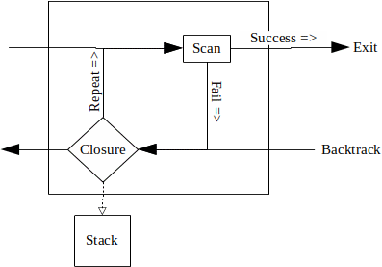Figure 1: SCOEL Extraction object and its internal workings
The extraction objects which are used to determine whether the information collected in the scan are stored on the stack, counted or disregarded. It uses a prefix system to identify which operation will be performed during closure:
- c_ (collate) stores the elements collected from a successful scan to the stack and combines them into a list of tokens.
- f_ (anchored fetch) anchored match described further below, stores the elements collected from a successful scan to the stack.
- F_ (unanchored fetch) unanchored match described further below, stores the elements collected from a successful scan to the stack.
- p_ (anchored pass) anchored match described further below, does not store the elements collected from a successful scan to the stack.
- P_ (unanchored pass) unanchored match described further below, does not store the elements collected from a successful scan to the stack.
- t_ (tabulate) returns the number of times it can find the scan successfully.

Eventually the chain of extraction objects is capped with a closure object. If one is not included in a pattern definition or a string extraction function is used, then a closure object with a &success argument is automatically used. But, when defining a pattern definition with a closure object, it can hold either a &success, &fail or &terminate argument for closure. While performing closure if &success message is passed back to the previous extraction object, it will push the results onto the stack. When a &fail or &terminate is sent back to the previous Matching object, the extraction object is skipped and nothing is stored to the stack.
- closure(&fail/&success/&terminate) Sets up the necessary components for backtracking and sends a message to identify the status of the string analysis.

Below is a diagram of the closure object, the scan object does not perform a scan, it is where it sets up the required components for the closure process and backtracks through the previous extraction objects.
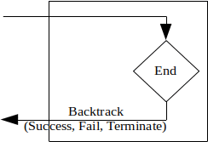Figure 2: Closure object

Pattern Definitions
When complex sets of instruction are required, those instructions can be combined into a pattern definition. A pattern definition is a series of Matching instructions with their respective scanning operations.
pat :- {
p_many(&letters)
f_many(&digits, 3)
f_any(&letters)
closure(&success)
}

The following diagram shows how the pattern definition above would be structured.
A pattern definition called pat has three extraction objects; the first passes a set of letters, second fetches the next three digits and then it fetches a letter, finally it encounters a closure object. Had there not been a closure object it would by default place a closure(&success) object on the end. A closure object can be given either of the &success, &fail, or &terminate keywords.
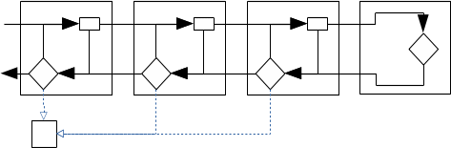Figure 3: Pattern definition structure
- closure(&success|&fail|&terminate) signifies the end of a pattern definition and what message to send when backtracking begins.
The following code illustrates how a fail message can be sent from the closure object:
pat := {
p_pass(&letters)
f_many(&digits, 3)
f_any(&letters)
closure(&fail)
}

Running this example will result in nothing being returned, because a fail message would be sent back during the closure operation and none of the closure methods will push their results on to the stack.

Additional Extraction Objects
Should it be necessary to change the message from either success or fail, the Fence object can be used to change the backtrack message to either success, fail or terminate. If SCOEL runs across one these objects during backtracking, it will change the message, but during the forward matching process it will do nothing.
- fence(&fail/&success/&terminate) changes the backtracking message at this point if it is either &success or &fail to the message selected.
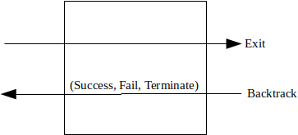Figure 4: Fence Matching Object
The following code is an example how this code could be used:
pat :- {
p_many(&letters)
f_many(&digits, 3)
fence(&success)
f_any(&letters)
closure(&fail)
}

str.f_any(pat)

This example differs from the previous, in a fence(&success) has been inserted between the f_many(&digits) and the f_any(&letters). The closure process will not add to the stack the results from the f_any(&letters) extraction object as it is sending a &fail message back until it encounters the fence where a &success message is sent back. Then it will push the results from the f_many(&digits, 3), the p_many(&letters) would not as it is a pass extraction object.

Structural Matching Objects available in Patterns only:
SCOEL uses implicit concatenation. Therefor, it is not necessary to create a Matching class to handle concatenation. By placing a match operation followed by another match operation in a pattern definition SCOEL will combine the results of both match operations if they are both successful.
The Or Matching object is called whenever an or symbol ‘|’ is used in a pattern definition. With an instruction of:
f_upto(&letters) | p_many(&digits)

SCOEL will try to fetch all the symbols up to a point where a letter is found. If it is success full in finding a letter, then it will store that information and proceed past the pass() match object. Should it fail, then it will move to the pass match object and attempt read some digits. If it finds any digits, then it will succeed, otherwise it will fail.
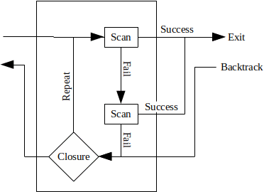Figure 5: Or extraction object
The Or ‘|’ extraction object succeeds when either branch of a pattern succeeds. Should the first branch succeeds then it does not try the second branch and reports the success. To use an Or extraction object it is placed in a pattern definition as follows
pat := fetch(any(‘a’)) | fetch(any(“bcd”))
str.f_any(pat)

In this example, there is a definition for pat in the first line. When the second line executed, the fetch will will first check to see if the next character in subject, if it is an ‘a’ then it will succeed and push the “a” to the stack. If it does not succeed, then it will try to find the sub-string “bcd”.
While defining a pattern it is sometimes necessary and useful to group some Matching objects together with the use of parenthesis. When this is done, a Parenthesis Structural Matching Object is created which controls the flow of the extraction process to keep those items within the parenthesis combined together. The figure below shows the flow of the extraction process when a parenthesis are used. When the extraction process enters the Parenthesis Structural Matching object it is immediately directed to the first Match object in the parenthesis and performs the scans for each object in order until it reaches the last item. It then exits upon success to continue down the pattern definition. When it returns during backtracking it is sent to the last Matching object in the parenthesis and performs any back scanning and resolution as defined.
In the example below, the pattern will find either a token with ‘abc’ followed by a bunch of letters followed by a bunch of digits or a token which starts with a ‘d’ followed by a bunch of digits. The parenthesis group the fetch and pass Matching objects together.
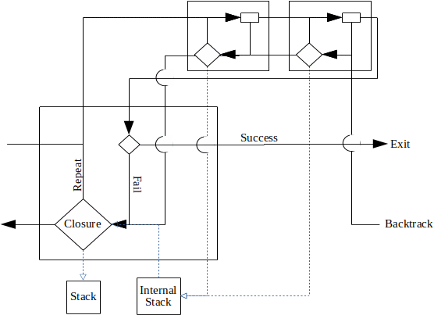Figure 6: Parenthesis extraction object
Pat := {
( f_any(“abc”)
p_many(&letters)
) | f_any(”d”)
f_many(&digits)
}

Assignments during extraction
The ability to assign the results of internal scans of a pattern is useful in being able to control the flow of pattern recognition. For example, you scan an integer value which tells you how many characters that follow, it can be assigned to a variable and then passed as an argument later in a scan later in the pattern. The three types of pattern assignments are the immediate assignment, the conditional assignment and the index assignment; similar to what is available in SNOBOL4.

Immediate Assignment
An immediate assignment is made when a pattern contains the following expressions:
pat :- {
p_many(&letters)
pos := self.pos()
closure(&fail)
}

or
pat :- {
p_many(&letters)
str := f_many(&digits)
f_many(&letters)
closure(&success)
}

This tells the information extraction system to assign the results of a match object to a variable called variable. It will make this assignment regardless to weather the complete matching operation is successful or whether the matching function stores the information on to the stack. The scan in the previous matching object must be successful.

Conditional Assignment
The conditional assignment is structured slightly different than the other two. It will only make the assignment during backtracking if a ‘success’ message is sent back to the assignment matching object. The conditional assignment operator is ‘->’.

Anchoring
The pattern matching system of SNOBOL4 allowed the programmer to determine whether they wanted the pattern match to be tied to the current index location or to progress through the string until it finds a match. This concept is called anchoring. If the pattern match is anchored then it will not progress through the subject string until it finds a match, it will only test from the current location.[2]
In SNOBOL4 the default mode is unanchored, or to scan the string until it finds a match. In Scoel the default mode is to be anchored, or to test for a match from the current index location only. Like SNOBOL4, Scoel allows the programmer to set the anchor mode. Scoel allows greater flexibility by allowing each pattern element to be set to either anchored or unanchored mode. To perform an unanchored extraction, use a capital letter at the beginning insteadt:
str.F_any(pat)

In this example, Scoel will look for a string of characters that match the pattern definition. Should it be necessary to differentiate which match objects in a pattern definition need to be anchored and others not it can be done as well:
pat := {
P_many(&letters)
f_many(&digits)
}
str.f_(pat)

In this example the pattern definition has an unanchored P_many() pattern element which will look for a set of letters in the string, then it will try to fetch a series of digits immediately after those letters.

